1) Abstract
Simultaneous Localisation and Mapping (SLAM) is a foundational capability for autonomous agents, conventionally achieved through the fusion of multiple high-quality sensors including LiDAR, cameras, and wheel encoders. This paper investigates the viability of achieving meaningful SLAM under a deliberately minimalist sensor configuration, using only a single HC-SR04 ultrasonic sensor for environmental perception and an MPU-6050 Inertial Measurement Unit (IMU) for odometry. The objective is not to compete with established multi-sensor systems, but to establish the lower bound of sensor complexity at which useful localisation and mapping remains achievable.

The agent is constructed on a two-wheeled chassis driven by micro-servo motors and controlled by an Arduino R4 Uno Wi-Fi, with SLAM processing conducted off-board via a Wi-Fi data pipeline to exploit a higher computational ceiling. A wall-following movement strategy is adopted to maximise scan density given the sensor's forward-facing 180° coverage. A FastSLAM-inspired implementation is selected as the primary algorithm on the grounds of its robustness to sensor noise and its logarithmic scaling with landmark count, and GraphSLAM post-processing is suggested as an offline refinement step following traversal completion. Performance is evaluated against two metrics: return-to-origin error, and comparison between a floor plan and mapping undertaken by the agent.

The findings contribute to an underexplored area of SLAM literature, that being the practical limits of minimalist sensing configurations.

2) Introduction
SLAM (Simultaneous Localisation and Mapping) refers to a process whereby an agent constructs a map of an unknown environment, or updates information about a known environment, while simultaneously keeping track of its own location within it. It is considered a crucial aspect for most autonomous agents, and has a wide array of industry uses, such as in robotic vacuums, warehouse automation, and self-driving cars.

Given its prevalence in such a wide array of contexts, a number of implementations exist, consisting of high quality sensors for both the environment around the agent, as well as high precision odometric equipment to ensure the agent can accurately locate its position within said environment.

For the environmental sensors, a combination approach is typically taken, with LiDAR (light detection and ranging), cameras, as well as sonar all being used. LiDAR is often considered the most potent sensor for agents due to its high precision analysis, and as such is generally afforded the most generous budget by manufacturers. Although generally providing less accurate results due to being more at risk to environmental issues such as lighting, cameras are also generally not neglected in most agents that seek to navigate dynamic environments.

On the other hand, sonar sensors generally exist solely as supporting sensors. Despite its commonality in SLAM implementations for obstacle avoidance, such as in the case of self-driving cars, very few rely on sonar alone, as the results provided by it are very susceptible to environmental changes, such as temperature, as well as its inability to distinguish between environmental features. Although a sonar sensor can inform an agent of the existence of an item in its environment, further information is hard to be obtained due to the low resolution of the beams in these ultrasonic sensors.

Moving on to the secondary aspect of SLAM, odometry, it is a similar situation to environmental sensing, in which multiple sensors are often used in conjunction in order to confirm the veracity of data. Wheel encoders are sensors that exist on the wheels of the agent themselves, measuring the number of revolutions of each wheel, allowing the linear displacement to be calculated. Camera and LiDAR solutions, as above, are also used in odometric sensing. Visual data from the camera can be used in order to estimate movement between frames, and the LiDAR sensors utilise a similar technique, albeit more accurately, to calculate the incremental changes in environment between consecutive 3D scans.
Inertial Measurement Units (IMUs) serve a similar purpose to the sonar sensors mentioned in the environmental scanning section; they largely exist as a supporting set of data for more accurate measurements taken with the above methods. IMUs utilise dead reckoning: calculation of an agent’s position by using a previously established position at 0, and taking into account estimates of speed, yaw (angle) and elapsed time in order to generate a rough position for an agent. These calculations rely largely on information that the IMU is simply unable to gather of its own accord, so supplementation of more accurate data from other sensors is almost always a necessity in most agents.

This report seeks to investigate the viability of achieving meaningful SLAM using only an IMU and a single ultrasonic sensor. This project aims not to match the performance of above systems, but rather to establish the limits of such an approach. These limitations create a very minimalist system, and data readings are likely to be inaccurate and infrequent, therefore any shortcomings of the data stream must be considered in advance in order to minimise them.

The remainder of this paper is structured as follows. Section 3 reviews prior work in the areas of ultrasonic SLAM, IMU-based odometry, and SLAM algorithm design, establishing the theoretical foundations and motivating the design decisions taken in this project. Section 4 outlines the project management approach, including research objectives and the project timeline. Section 5 describes the hardware comprising the agent, including the rationale for each component selection. Section 6 details the methodology, covering the movement strategy, scanning procedure, pose estimation approach, SLAM algorithm, and evaluation framework. Section 7 documents the implementation of the system. Section 8 presents the experimental results, and Section 9 discusses their significance in the context of the research objectives and the wider literature. Section 10 concludes the paper and outlines directions for future work.

3) Background & Literature Review
In [1], the inherent limitations with ultrasonic sensing are discussed, in particular the main flaws described include their “large angular uncertainty” and false data associations causing an inevitable divergence in the robot’s perceived position. Due to this, the authors used a camera alongside the ultrasonic sensor because of the visual sensor’s ability to gather abundant information for data association. In the end, the authors conclude that this is a high performing solution to mapping of indoors apartments, praising its high feature detection. The positive results in this paper, however, cannot be afforded solely to ultrasonic sensing, highlighting its insufficiency as an individual sensor in most settings, reinforcing the notion of sonar’s existence as a complementary sensor.

The robot discussed in [2] is a solely ultrasonic agent, however this design utilises six sensors to provide full 360º coverage. The conclusion of this paper acknowledges that the sonar scans were able to produce results very similar to that of a LiDAR scanner for an indoors environment, with an accuracy of ~95%. This highlights the viability of ultrasonic scanners as a sensor for SLAM, however the presence of wheel encoders in this report as well as the wide coverage afforded by the multiple scanners mean that the accuracy is likely to be higher than what will be achieved in this project. The combination of both a fundamentally more drift-prone method of odometry in the use of an IMU, as well as the presence of only a single sensor, forms the expectation that the agent in this report will perform considerably worse, and this report will investigate by how much.

A similar odometry setup is discussed in [3], where an agent utilises only a single IMU to navigate an environment. Through the use of deep neural networks to adjust the parameters of a Kalman filter, an average translation error of 1.10% is achieved, which the paper claims is comparable to top rated methods that generally use LiDAR or stereo. However, a difference in the setting of the [3] is in the use of sophisticated ML (machine learning), as well as the use of the KITTI driving dataset, and can therefore be considered as a best-case IMU scenario. This report’s implementation will likely show a higher drift.

[4] provides a probabilistic treatment of SLAM, demonstrating that the errors between landmark estimations are correlated, and that map accuracy is bounded by the accuracy of the first landmark observation taken. This paper establishes that the quality of initial observations for SLAM agents is crucial, even more so in the case of this paper wherein the environmental data is provided by a single ultrasonic sensor.

[5] is considered a foundational paper in the field of SLAM, and it discusses in detail the EKF-SLAM method, which is a common probabilistic algorithm that attempts to estimate a robot’s estimated position as well as the position of landmarks using an extended Kalman Filter (EKF). The paper also discusses the issue of computational power inherent to EKF-SLAM, in particular the problem of computational power growing quadratically with the number of landmarks in an environment, inspiring the decision to keep environments simple and easily navigable for the purposes of this project. However, low feature environments could also potentially cause the issue of an agent being unable to localise itself correctly, therefore a balance must be created with regards to the complexity of the environment.

[6] is a follow-up paper to [5], and discusses the matter of complexity scaling with the number of landmark features, as well as methods to decrease this complexity for easier computation. In particular, the concept of partitioned updates are discussed, wherein rather than applying changes to a global map with every update, updates instead happen more frequently at a local level, with the global map being updated at a lower frequency. Given the inherent inaccuracy with the scanning methods utilised for the agent in this paper, collating smaller scale scans into a larger global map could be a way to minimise error, as drift can be occasionally reset by having the agent assume its new position at zero. Furthermore, [6] warns that incorrect data association can cause “catastrophic failure” in localisation due to map divergence, which may pose a significant risk for this agent due to the noisy, low-resolution sensor data used, requiring cautious handling.

[7] discusses another interesting method of evaluating the performance of an agent, and that is the “explore and return” method, wherein an agent attempts to return to its starting position after scanning is complete. A combination of this evaluation technique, as well as a comparison between floor plans and the agent’s recorded data will both be used in this paper as an attempt to more accurately calculate the drift in perceived position by the robot.

[8] details an algorithm for the localisation of an agent, involving the use of “geometric beacons”, a naturally occurring, static environment feature that can reliably be observed with sensor measurements. Two implementations are discussed within this paper, both of which utilise sonar, therefore this may be a viable method of having the agent reorient itself in the case of extreme drift causing localisation errors. However, the algorithm utilises an a priori map of known beacons, rather than being a fully unknown environment. In order to keep this report more in line with a standard SLAM agent, this will be carried out in real-time rather than provided a priori, with the agent identifying very strong features it is confident about as beacons which can later be used to reorient itself.

[9] discusses another ultrasonic agent, particularly relevant due to it containing a single ultrasonic sensor, and in particular details a triangulation method for identifying landmarks. Under the assumption that the same target will return a signal if two scans are performed from slightly different positions, it is possible to get a more accurate estimate of the target location through triangulation. The paper produces promising results, in particular allowing for high accuracy estimation of prominent sonar targets like walls and doorways, showcasing the potential of minimalistic sensor configurations being able to identify meaningful landmarks in SLAM.

Although a general EKF-SLAM approach is suitable for most agents, [10] discusses a flaw with this approach, in which linearisation can cause errors to accumulate, causing divergence in results where scanning data is inaccurate. In more accurate sensors such as cameras, this doesn’t pose as much of an issue, which can be seen through the prevalence of EKF in the field of SLAM, however, for the agent discussed in this paper, where data errors fundamentally have a high chance of occurring, this divergence poses a much stronger threat. Hence, alternative approaches must be considered in an attempt to maximise the potential of this agent.

One of these alternatives could potentially be the use of an Unscented Kalman Filter (UKF). Discussed in [11], some advantages noted about UKF-SLAM include a lower sensitivity to data errors, at the expense of a higher computation cost. One of the few advantages of using an ultrasonic sensor is that data is relatively simple to work with, and, as will be discussed further in Section 5, most data handling in this project will be occurring off-board, thus providing a higher computational ceiling to work with. Although [11] concerns itself with a dynamic environment, rather than the static environment intended for this agent, the improved handling of nonlinear systems remains applicable regardless of environmental dynamism, and the paper’s results still demonstrate a meaningful improvement over standard EKF under conditions of sensor noise.

Another potential method that could be utilised is Particle Filter SLAM (PF-SLAM). A popular implementation of PF-SLAM is FastSLAM, noted for its tendency to scale logarithmically with the number of landmarks in the environment, as noted in [12]. Through the use of “particles” to represent multiple potential robot locations, agents are able to maintain a distribution of possible poses rather than committing to a single estimate, which could help recover from severe drift events. This approach is particularly well suited to use alongside geometric beacons as described in [8], since distinctive, reliably observable features provide strong update signals that allow the particle distribution to converge rapidly on the correct pose.

The final method to be evaluated is known as GraphSLAM. This is an Offline SLAM method, meaning that data is processed post-collection, in order to optimise map and trajectory accuracy. [13] describes how this method represents the collected data as a sparse graph of constraints, which are resolved into a globally consistent map using an information-form representation. However, [13] also notes the algorithm’s reliance on a reasonable initial map estimate, which could prove problematic given the unreliability of the ultrasonic sensor as a means of gathering environmental data. GraphSLAM will be considered as a post-processing refinement step in the case that the agent successfully navigates its environment and produces a sufficiently coherent initial map.

The literature reviewed above establishes both the theoretical foundations of SLAM as well as the practical capabilities of both IMU odometry and ultrasonic sensing as means of carrying it out. Individually, sonar-based SLAM has demonstrated viability when supported by sufficient sensor coverage, while IMU-only odometry has demonstrated a high performance in ideal conditions, despite its drift-prone nature. Multiple algorithmic approaches exist to handle the noise and nonlinearity inherent to such projects, and many viable techniques were discussed above, ranging from UKF to offline-based optimisation. However, there is minimal work investigating the potential for this minimalist sensing approach to produce any meaningful results. This project seeks to establish where the bounds lay for such an agent, and to determine what quality of localisation and mapping is achievable under these constraints.

4) Project Management

4.1 Research Objectives
The primary aim of this project is to investigate the viability of achieving meaningful Simultaneous Localisation and Mapping using only an IMU and a single ultrasonic sensor. In pursuit of this aim, the following research objectives have been established:

- To design and construct a minimalist robotic agent capable of navigating a constrained indoor environment using only an MPU-6050 IMU and a single HC-SR04 ultrasonic sensor.

- To implement a FastSLAM algorithm capable of producing a geometrically coherent map from the sensor data gathered by this agent.

- To quantify the positional drift accumulated under IMU-only dead reckoning across a full perimeter traversal.

- To evaluate whether GraphSLAM post-processing can meaningfully correct the drift present in the live FastSLAM output.

- To establish to what extent a robot with this design is able to accomplish this task, and if it is unable to, what the assumed necessary minimum for such a system would be. Regardless of success or failure, the metrics produced by the agent will be evaluated against other SLAM agents that utilise different sensors.

These objectives will serve as the basis for evaluation in Section 9, against which the success of the project will be assessed.

4.2 Project Lifecycle
This project is framed as a research paper rather than a software development project in the traditional sense. Nevertheless, it adheres to several principles established in the recognised software development lifecycle. The stages addressed are as follows.

Requirements are established through the sensor and environmental constraints detailed in Sections 5 and 6.4. These constraints define the operational boundaries of the system and inform all subsequent design decisions, serving the equivalent function of a requirements specification.

Design is addressed through the methodology presented in Section 6, which covers the movement strategy, scanning procedure, pose estimation approach, SLAM algorithm selection, and evaluation framework. Each design decision is motivated by either the hardware constraints of Section 5 or the findings of the literature review in Section 3.

Implementation will be documented in Section 7, covering the software written to run on the Arduino R4 and the off-board processing pipeline.

Verification will be addressed in Section 8 through experimental testing, the results of which will be evaluated in Section 9 against the objectives stated in Section 4.1.

4.3 Project Timeline
The project was conducted across the academic year, with work divided into the phases illustrated below.

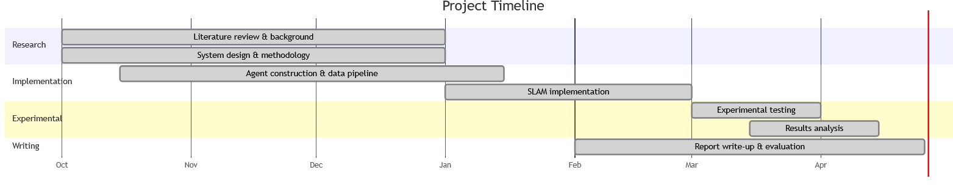

The literature review was conducted first in order to ground all subsequent design decisions in existing work, particularly with regard to algorithm selection and the known limitations of the chosen sensor types. Hardware procurement and construction ran concurrently with the later stages of the literature review, allowing the physical constraints of the build to inform the methodology before it was finalised. Software implementation followed the completion of the methodology, with experimental testing conducted thereafter. Report writing was carried out progressively throughout the project rather than reserved for the final phase, in order to ensure accurate documentation of decisions at the time they were made.

4.4 Technology and Tooling Decisions
Several critical technology decisions were made during the planning phase of this project, each of which influenced the scope and design of the system. These are summarised here; fuller justification for choices made is provided in Section 5.

The decision to process SLAM off-board via the Arduino R4's onboard Wi-Fi module, rather than on the microcontroller itself, was made early in the planning phase upon assessment of the RAM and processing constraints of the hardware. This decision substantially raised the computational ceiling available to the SLAM algorithm, enabling the use of FastSLAM and GraphSLAM approaches that would not be feasible within the Arduino's resource constraints. The trade-off introduced by this approach is the addition of latency in the pipeline, which is acknowledged and addressed further in Section 5.

The decision to use Python for off-board processing was made on the basis of its extensive ecosystem of scientific computing libraries, including NumPy and SciPy, which provide the numerical foundations required for the Kalman filter operations central to both FastSLAM and GraphSLAM.

The decision to adopt a stepwise movement strategy, rather than continuous motion, was similarly a planning-phase decision driven by the known susceptibility of IMU accelerometer readings to motor vibration noise. This significantly constrained the operational speed of the agent but was judged to be a necessary trade-off to obtain usable scan data at each pose.

5) System Design & Hardware
In line with the introduction, the hardware for this robot has been selected in order to be a minimalist, low-cost implementation. Each component has been selected with the greater scope of the project in mind, and this section will detail the choices made for this project.

The robot is constructed on a 2WD metallic chassis, utilising two simple micro-servo motors being driven by a Dual TB6612FNG motor driver. A common approach to the motorisation of agents is the use of motors with encoders, which convert rotations into electrical pulses, in order to improve the accuracy of odometry by tracking speed and direction more precisely. However, these encoders have been eschewed in this project in order to maintain the minimalist configuration. Micro-servo motors don’t offer the same functionality provided by encoder-based motors, and while they do theoretically offer a decent degree of positional control, in practice their accuracy is affected by wheel slip, uneven surfaces, and variations in voltage.

The IMU used is an MPU 6050. The MPU 6050 utilises both an accelerometer, which measures linear acceleration, and a gyroscope, which measures angular rotation. This combination allows it to measure rotation along all three axes, as well as acceleration, which allows for the estimation of displacement, though without the assistance of other methods of odometry, the IMU has no other data against which to compare its own results, making it potentially prone to drift in position as the sole source of data. The MPU 6050 is taped flat to the chassis of the robot, and given a few seconds upon launch in order to initialise its own position before movement begins.

The ultrasonic sensor is an HC-SR04, a common sonar sensor that works through the emission of a 40KHz sonic pulse, and measuring the time it takes for the pulse to return after reflecting off of a target. It is prone to the same issues as many consumer ultrasonic sensors, those being its range, holding an effective maximum of 400cm, its volatility in hot or humid environments due to their slowing effect on sound waves affecting range accuracy, as well as an issue performing scans on soft materials due to their partial absorption of the emitted signal. These constraints majorly advise the limitations that will be placed on the experimental environments, though this will be discussed further in the methodology section. This sensor is mounted on a simple sweeping servo that allows for 180º of range, providing an even scan of the front side of the robot.

This project is running off of an Arduino R4 Uno Wifi, which contains a wifi module allowing for data to be returned to a computer for off-board processing. Processing SLAM on-board in real time is computationally expensive for this hardware, in part due to the limited RAM and the lack of an Operating System. Offloading this computational burden to a laptop allows for the running of more sophisticated algorithms, however some latency is introduced to the system through this pipeline, which may cause positional uncertainty to accumulate over time. Given the hardware constraints, this is an acceptable trade-off, and its effect on accuracy will be considered in the results analysis.

The robot will be running on 4 AA alkaline batteries, which, although sufficient for the scope of this project, are known to have a low life in high-drain motorised components, and therefore this agent won’t be subject to any long runs and will be limited in the environments it can operate in.

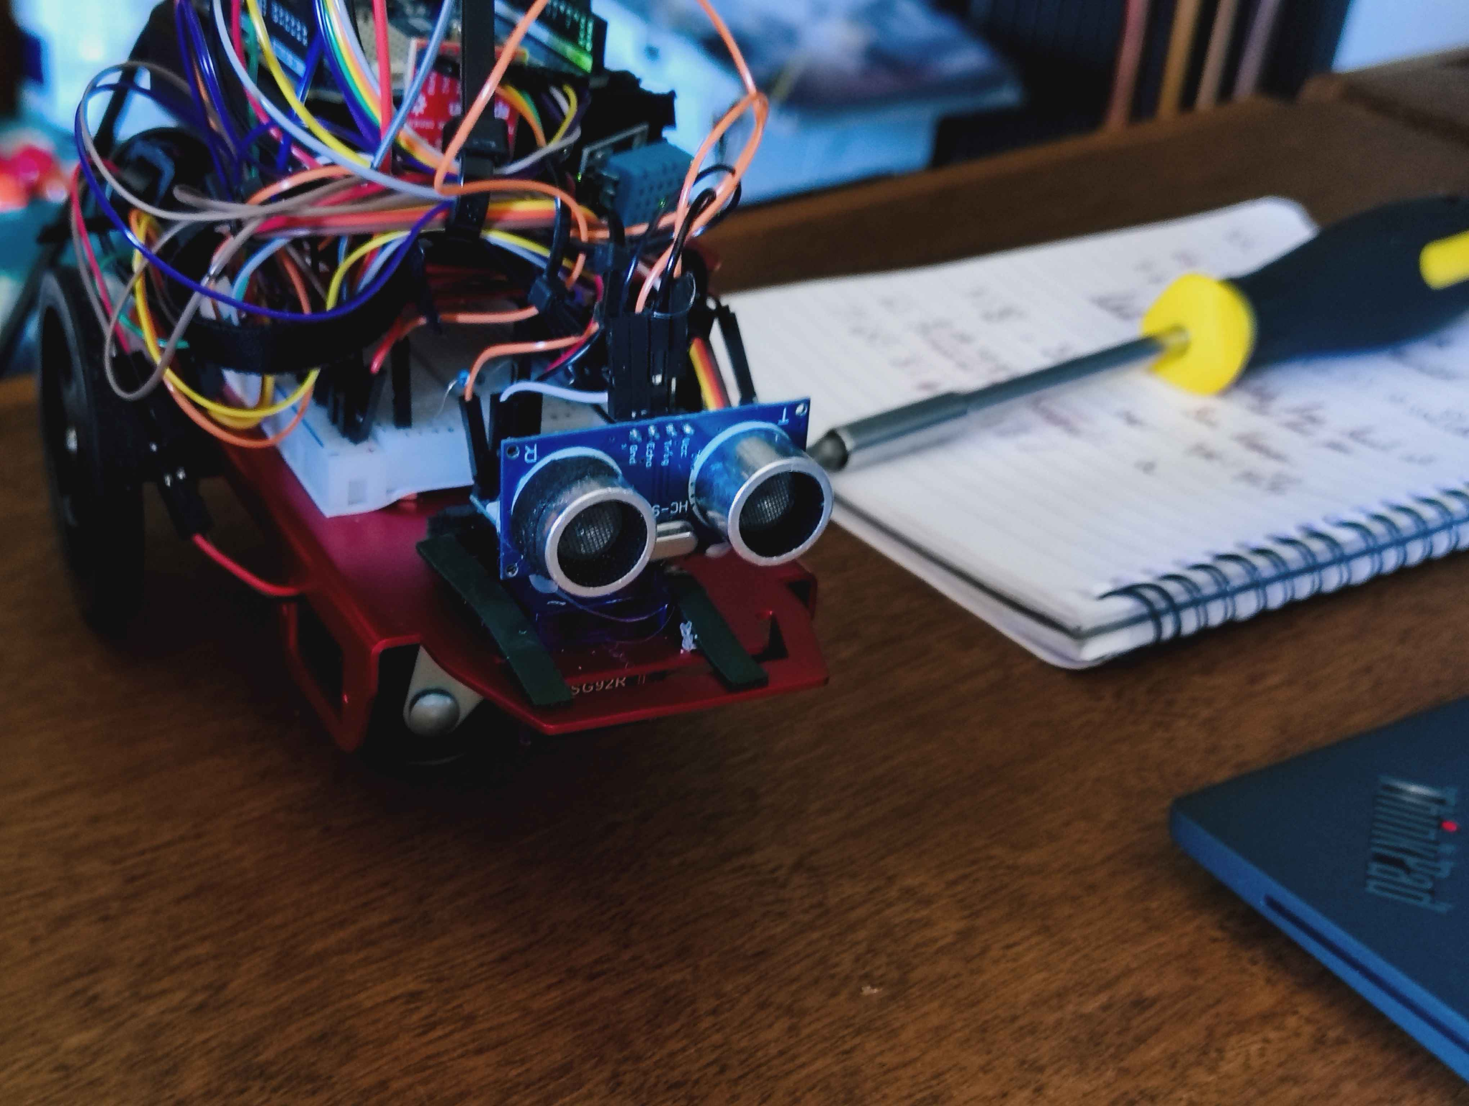 | 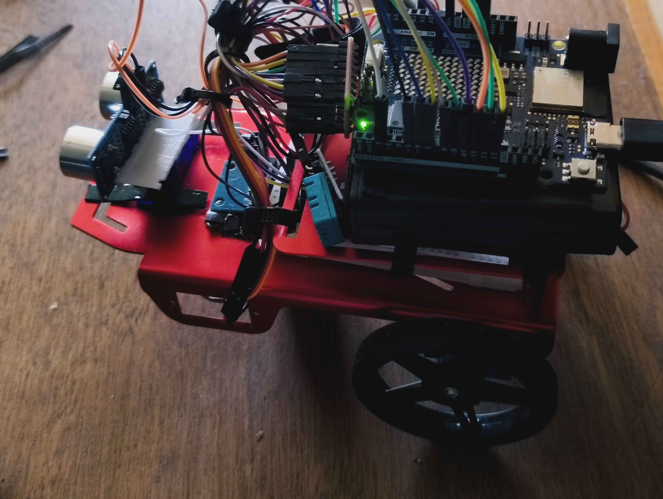

6) Methodology
This section details the intended design and implementation of the SLAM agent, encompassing the movement strategy, scanning procedure, pose estimation, algorithmic approach, and the constraints that will be placed on the environments in which the agent will operate. Each design decision is informed by the constraints of the hardware described in Section 5 and the findings of the literature reviewed in Section 3.

6.1 Movement Strategy
Given that the HC-SR04 is mounted on a forward-facing sweeping servo providing 180° of frontal coverage, the robot has no perception of the environment behind it. This makes free-roaming an unviable movement strategy, due to a large portion of the environment remaining unobserved. Instead, a wall-following approach will be utilised, wherein the robot maintains a consistent proximity to the nearest wall whilst navigating the perimeter of the environment. This ensures that the sensor is consistently directed toward observable surfaces, maximising the density of useful readings per unit of distance travelled. Wall-following also naturally produces a closed traversal loop, which is a prerequisite for the explore-and-return evaluation method discussed in Section 3.

Movement will proceed in discrete steps rather than continuously, the robot will advance a fixed distance, pause, perform a full sweep, then advance again. This stepwise approach is necessary because IMU-based pose estimation is subject to vibration noise from the motors, which would cause a disturbance in accelerometer readings. By pausing during each sweep, cleaner sensor data can be obtained and the positional estimate at each scan point can be treated as a discrete, reliable pose.

All motion commands are executed in an open-loop manner, meaning the robot does not verify the outcome of a movement after issuing a command. This introduces uncertainty in both translational and rotational motion, particularly for heading estimation, and is expected to contribute significantly to accumulated drift, but is implemented regardless due to the difficulty associated with the agent verifying its own movement with such minimal sensors.

6.2 Scanning Procedure
At each pause point, the sweeping servo will rotate the HC-SR04 across its 180° arc in fixed angular increments of 5°, producing 37 range readings per sweep. At each angular position, five readings will be taken in rapid succession and averaged, reducing the effect of spurious returns that are common in consumer ultrasonic sensors. Readings that fall outside the effective range of the HC-SR04 or that deviate significantly from the mean of the five samples will be discarded as noise.

Landmark extraction will follow the triangulation method described in [9]. By comparing returns from two consecutive sweep positions, separated by the robot’s known step distance, it is possible to estimate the position of a surface more accurately than a single reading allows. Features that produce consistent, strong returns across multiple sweep positions, such as flat walls and doorways, will be identified as landmark candidates. This is consistent with the geometric beacon approach of [8], wherein reliable, naturally occurring structural features are preferred over arbitrary point landmarks. However, unlike in [8], this is occurring in real time, keeping more in line with traditional SLAM, rather than the beacons being provided a priori. Soft surfaces and irregular objects will produce inconsistent returns and will therefore be filtered out, which also aligns with the environmental constraints discussed in Section 5.

6.3 Pose Estimation via Dead Reckoning
The robot's pose, comprising its x and y position and heading θ, will be estimated through dead reckoning using the MPU-6050. The robot's starting position is defined as the world origin (0, 0) with an initial heading of 0°. At each movement step, the gyroscope provides heading updates by integrating angular velocity over the duration of the movement. Linear displacement is estimated by double-integrating accelerometer readings over time, from which the change in x and y position is calculated using the current heading.

It must be acknowledged that double integration of accelerometer data is inherently prone to error accumulation, as any noise in the accelerometer readings will be accentuated through the calculations. This is the fundamental source of IMU drift discussed in [3], and without the neural network correction employed in that work, drift in this implementation is expected to be considerably higher. Two measures will be taken to minimise this. First, a calibration period of several seconds will occur at startup, during which the robot remains stationary and the IMU establishes its bias baseline. Second, a zero-velocity update will be applied during each pause between movement steps. Since the robot is known to be stationary during sweeps, any non-zero velocity reading from the accelerometer at these moments can be attributed to bias and corrected accordingly. This simple technique substantially reduces drift accumulation without requiring additional sensors. Once the agent has established a number of landmarks, as discussed in Section 6.2, it can use these to orient its position in the environment more accurately based on previous readings, which are more likely to be accurate due to the accumulation of drift over time.

6.4 Environmental Constraints
The reliability of both the HC-SR04 and the IMU is highly sensitive to environmental conditions, and as such the experimental environments used in this project will be subject to strict constraints informed by the sensor limitations described in Section 5.
All surfaces within the test environment must be hard and flat. Soft materials such as curtains or upholstered furniture partially absorb the ultrasonic pulse, producing weak return signals that cannot be reliably used for landmark extraction. Irregular surfaces introduce unpredictable multi-path reflections that undermine the triangulation method. The environment must therefore consist primarily of flat, hard-surfaced walls which produce strong, consistent returns suitable for geometric beacon identification.

The environment must be maintained at a stable indoor temperature throughout testing. As noted in Section 5, temperature affects the speed of sound and therefore the range accuracy of the HC-SR04. Significant temperature variation between scans would introduce systematic range errors that cannot be corrected without a temperature-compensated sensor. Testing will therefore take place in a single indoor room with no external airflow, heating activity, or significant heat sources nearby.

The physical dimensions of the test environment must fall within the effective range of the HC-SR04. Given its maximum effective range of approximately 400cm, environments will be limited to rooms no wider than 350cm to ensure full wall-to-wall coverage is achievable from any scan position, with a margin retained for reliability. Battery constraints discussed in Section 5 further limit the total run length of the agent, and therefore environments will be kept small enough to complete a full perimeter traversal within a single battery charge.

6.5 SLAM Algorithm
The primary SLAM algorithm implemented in this project will be FastSLAM, a particle filter-based approach described in [12]. FastSLAM represents the robot's pose as a distribution of particles, each constituting a hypothesis about the robot's current location. This is particularly well-suited to the constraints of this project for two reasons. First, unlike EKF-SLAM, FastSLAM does not rely on linearisation of the system model, avoiding the divergence risk identified in [10] that is especially pronounced with noisy sensor data. Second, its logarithmic scaling with the number of landmarks makes it computationally manageable, especially when processed off-board via WiFi, as described in Section 5.
Landmarks will be defined as geometric beacons following [8], specifically walls and doorways identified through the triangulation procedure described in Section 6.2. The particle filter will maintain a separate landmark estimate for each particle, updated upon each new observation. When a new scan produces a return consistent with a previously observed landmark, the corresponding particles are reweighted accordingly, allowing the distribution to converge on the most probable pose. When no prior landmark matches the observed return, a new landmark is initialised in the map.

Data association, the process of matching new observations to existing landmarks, represents the highest risk point in the pipeline. As [6] warns, incorrect data association can cause catastrophic divergence. To mitigate this, a conservative association threshold will be applied, wherein a new observation is only matched to an existing landmark if the Euclidean distance between them falls within a tight bound. Observations that do not meet this threshold will either initialise new landmarks or be discarded, rather than risk a false association corrupting the map.

6.6 GraphSLAM Post-Processing
As discussed in [13], GraphSLAM is an offline optimisation method that represents the agent's trajectory and map as a graph of pose constraints, which are then resolved into a globally consistent solution. Given the expected accumulation of drift during live operation, GraphSLAM will be applied as a post-processing step once the agent has completed its traversal and the full dataset has been transmitted off-board.

The pose graph will be constructed from the sequence of discrete scan positions recorded during operation, with edges representing the relative pose transformations estimated by the IMU between each step. Landmark observations will provide additional constraints linking non-consecutive pose nodes where the same beacon is observed from multiple positions. The graph will then be optimised to minimise the total constraint error, producing a refined trajectory and map that corrects for accumulated drift.

It is acknowledged, as noted in [13], that GraphSLAM's performance is dependent on a reasonable initial map estimate. If the live FastSLAM output is too inaccurate to provide a coherent initial graph, post-processing optimisation may not converge meaningfully. This will be treated as a secondary result: the quality of the GraphSLAM output relative to the FastSLAM output will itself serve as an indicator of whether the live mapping was sufficiently accurate to be refineable.

6.7 Evaluation
Two metrics will be used to evaluate the performance of the agent, drawing on the methods established in the literature.
The primary metric is return-to-origin error, following the explore-and-return method of [7]. Upon completing a traversal, the agent's estimated position will be compared to its known starting position. The Euclidean distance between these two points constitutes the return error, expressed in centimetres. This provides a direct, single-figure measure of accumulated positional drift over the full traversal.

The second metric is map accuracy. The agent's generated map will be compared against the measured floor plan of the test environment, and the correspondence between mapped wall positions and true wall positions will be evaluated. This provides a spatial measure of mapping quality.

Both FastSLAM and GraphSLAM outputs will be evaluated against both metrics, allowing the contribution of post-processing to be quantified independently.

7) Implementation

7.1 Arduino Firmware

The firmware is written in C++ using the Arduino framework and is responsible for sensor acquisition, motor control, and network communication. It runs on the Arduino R4 Uno Wi-Fi and communicates with the off-board Python process over a TCP socket connection.

Upon power-on, a gyroscope calibration sequence is then performed: 1000 raw z-axis readings are collected at 2ms intervals while the robot remains stationary, and their mean is stored as a bias offset. This value is subtracted from all subsequent gyroscope readings prior to conversion into degrees per second, providing a simple correction for zero-rate bias.

The firmware blocks until a client connection is accepted, whereupon it enters its main command loop. Upon receipt of a MOVE command, the firmware drives both motors forward for a fixed duration of 240ms. The PWM values applied to each motor (leftSpeed = 150, rightSpeed = 108) were assigned through trial-and-error to produce approximately straight-line travel, compensating for the asymmetric torque output of the two micro-servo motors. Following the drive phase, the firmware enters a 300ms settle period during which the gyroscope continues to be integrated to capture any residual heading change after the motors stop. The total yaw change accumulated across both phases is packaged into an ODOM response message and transmitted to the Python host.

Turn commands drive the motors in a differential configuration for 250ms, followed by a 200ms settle period. As mentioned in Section 6.1, all movements are made based on estimates of how an agent will move given a specific driving duration, due to the lack of accurate data for the agent to inform itself when it has actually turned a certain amount. While the heading change is captured via continuous gyroscope integration during both phases, the Python host does not use the reported yaw delta for turns during normal operation; a fixed TURN_ANGLE_EST value is used instead. This decision was made during testing, as the reported gyroscope yaw for turns was found to be unreliable under the vibration conditions of the motorised turns.

For sweep operations triggered by a SCAN command, the servo is stepped across its range from 0° to 180° in 5° increments, with a 150ms settle delay at each position to allow the servo to reach its target angle and for acoustic reflections to dissipate. A mechanical trim offset of -22° is applied to the servo write value at each position to correct for a misalignment in the servo mounting bracket. At each angular position, five distance readings are obtained from the HC-SR04 at 15ms intervals; readings outside the 2–350cm validity range are discarded, and the remaining values are averaged. The sweep output is transmitted as a sequence of angle-distance pairs, followed by a POSE message containing the current dead reckoning estimate.

7.2 Off-Board Processing Pipeline

The Python processing pipeline handles all SLAM computation, navigation decision-making, and post-session visualisation. It communicates with the Arduino firmware over a TCP socket, issuing commands and parsing responses via a line-buffered protocol handler.

Particle filter state is maintained as a list of 120 Particle objects, each carrying an (x, y, yaw) pose hypothesis and an accumulated path history. All particles are initialised at the world origin with zero heading, consistent with the robot's known starting pose. Motion updates are applied via the commanded_motion_update function, which propagates each particle's pose according to the issued command (MOVE, TURNL, or TURNR) with additive Gaussian noise applied to both position (σ = 0.35 cm) and yaw (σ = 1.5°) to model the open-loop motion uncertainty described in Section 6.1.

Scan points received from the Arduino are transformed from the sensor's polar frame into world coordinates based on each particle's current pose estimate using the scan_to_world function. All transformed points are accumulated into a global map list. To manage memory growth and suppress noise, a grid-based consolidation step (consolidate_map) is applied after each scan: the map is discretised into a 5 cm grid, and only cells with a minimum of three contributing observations are retained, represented by the centroid of their contributing points.

Measurement update weights each particle according to the alignment between its projected scan and the consolidated global map. For each transformed scan point, the squared nearest-neighbour distance to the existing map is computed, and a Gaussian likelihood with σ = 8 cm is evaluated. The accumulated likelihood across all scan points constitutes the particle's unnormalised weight. Weights are then normalised across all particles and systematic resampling is applied, producing a new particle set that samples from the posterior pose distribution with lower variance than naive multinomial resampling.

Landmark extraction is applied to the consolidated map after each scan. DBSCAN clustering (ε = 14 cm, minPts = 4) groups spatially proximate map points into coherent surface regions. RANSAC line fitting (80 iterations, inlier threshold 5 cm, minimum 6 inliers) is then applied to each cluster to extract linear features corresponding to walls and other planar surfaces. A least-squares line is fitted to the final inlier set to produce the landmark representation. Detected lines are matched against the persistent landmark memory by comparing angular similarity and midpoint proximity; matched landmarks are updated via an exponential moving average with α = 0.2, while unmatched detections initialise new landmark entries.

Navigation during the exploration phase is governed by a sector-based wall-following heuristic. Scan returns are divided into three angular sectors: front (70°–110°), front-left (100°–140°), and left (120°–170°). If the minimum return distance in the front or front-left sector falls below 28 cm or 30 cm respectively, a right turn is issued to avoid collision. If the left sector minimum exceeds 95 cm, a left turn is issued to re-acquire the wall. Otherwise, a forward step is issued. This produces a left-hand wall-following behaviour consistent with the movement strategy described in Section 6.1.

Upon completion of the exploration phase, the return-to-origin (RTO) error is computed as the Euclidean distance from the best particle's estimated position to the world origin. Following this, the robot attempts to navigate back to the origin by issuing corrective turns aligned to the origin bearing, interspersed with forward steps. The return phase uses the frozen exploration map without incorporating new scan observations, preserving the exploration-phase map for evaluation. Physical return is aborted if the estimated distance to the origin fails to improve across five consecutive forward steps, preventing the robot from diverging further in the case of significant accumulated drift.

At session completion, the pipeline produces a visualisation rendering the accumulated global map, DBSCAN clusters, stable RANSAC landmarks (those observed across three or more distinct scan positions), the exploration path, and the physical RTO trajectory where applicable.

It should be noted that this implementation is FastSLAM-inspired rather than a complete FastSLAM implementation. In standard FastSLAM, each particle maintains its own independent landmark map and associated uncertainty estimates. In this implementation, particles represent pose hypotheses while mapping is performed through a shared global point map and persistent landmark memory. Map uncertainty being represented individually for each particle generally lends itself well to data association, but as mentioned in the literature review, a reliance on data association with unreliable data can cause critical failure with localisation, and so considering the small scale of the environments, this implementation was deemed sufficient.

8) Experiments & Results
Testing primarily took place in two environments. One of these was an open space with a wall on the right side and a table leg on the left. Further ahead in front of the agent was a plant pot. The pot and table leg are both curved, which serves as an attempt to gauge the agent's ability to identify curved features in the environment. This was also the space in which most mid-development testing occurred, and hence parameters may have become biased towards this environment.
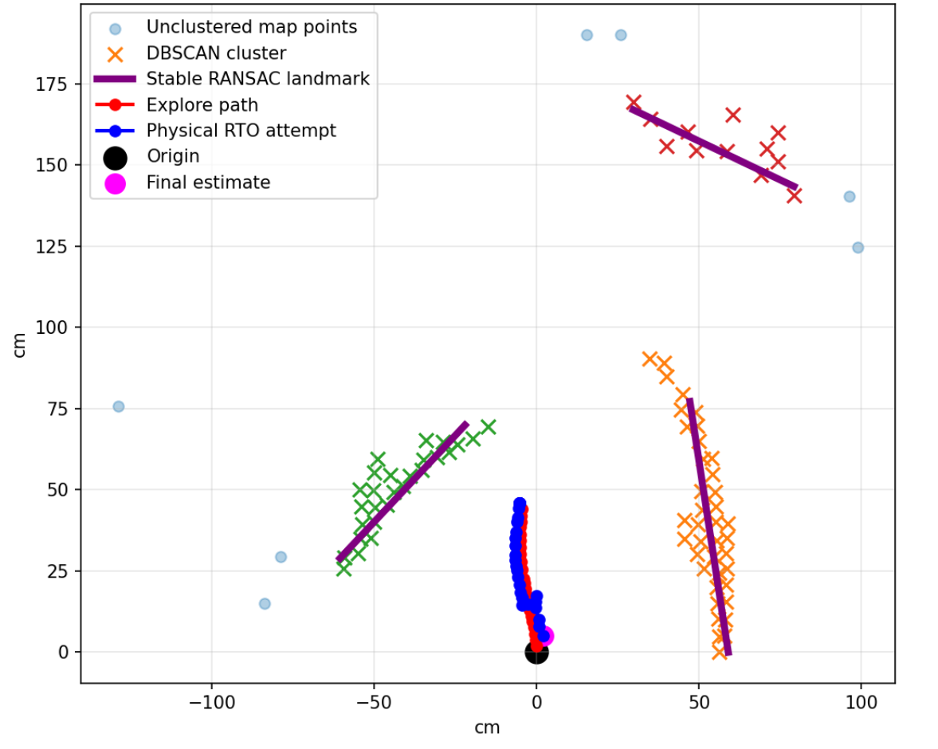
Figure 1

Above is an example map of what a run of the agent in this environment looks like. As can be seen by the red line, which is the path the agent traversed while carrying out scans, distance was highly limited in these runs, with the agent only making 25 moves in the exploratory phase. This was a limitation placed in order to minimise runtime as it is a slow-acting agent, however even in this short run some of the capabilities of the agent can be gleaned. As can be seen by the DBSCAN clusters utilised, the agent was able to identify the three distinct features in the environment, albeit with some flaws. The agent perceives the table leg (in green) to be vastly long compared to its actual dimensions, a flaw that could likely be attributed to its circular shape in addition to the beam shaped nature of the ultrasonic scans causing some anomalous results.

The pot (red cluster) was also identified, albeit with some serious divergence in its actual shape compared to its measured dimensions. This could be attributed to the distance at which the measurements were taken, highlighting the ultrasonic sensor’s lack of accuracy at range, although in consideration of the HC-SR04’s ~4m accurate range, this may simply be a result of the agent not being allowed to run long enough.

The wall (orange) is much more convincingly identified, with much of the cluster remaining straight. This changes further into the run, as curving can be seen further down the cluster, which could be a result of the accumulated drift of the IMU after the agent has been running for a longer period of time.

Regarding the capabilities of the IMU, an attempt at return-to-origin can be seen in the blue line. Despite the agent’s internal model holding the view that it had completed a return with ~5.5cm of error, in actuality, the robot returned to a position around ~20cm away from its origin. This discrepancy between its internal view of its own position and its actual position are likely the fault of the IMU not providing accurate enough information for the agent to travel in the correct direction. Although it managed to turn around, attempts to move in the correct direction were inaccurate enough as to majorly offset its position.
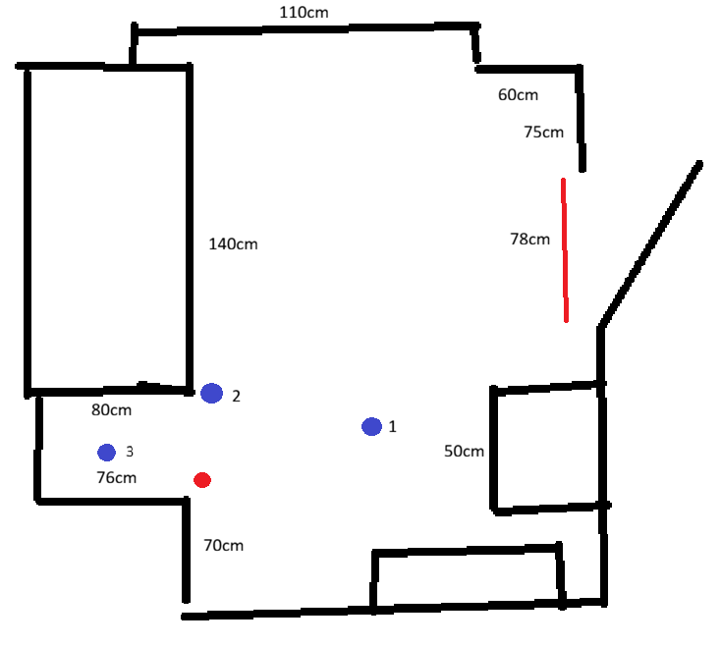 | 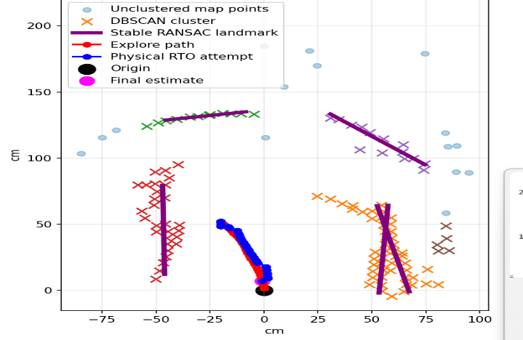
Figure 2 Figure 3
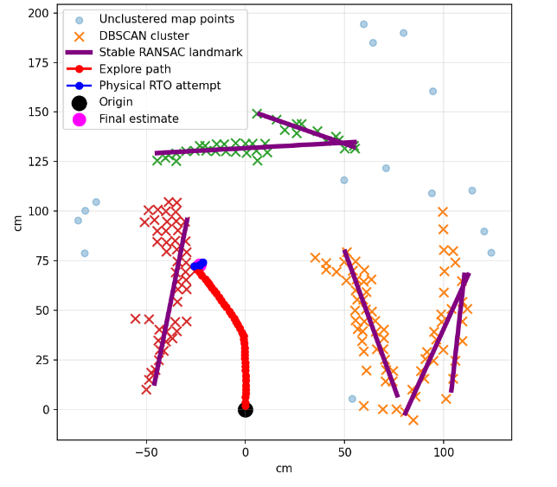 | 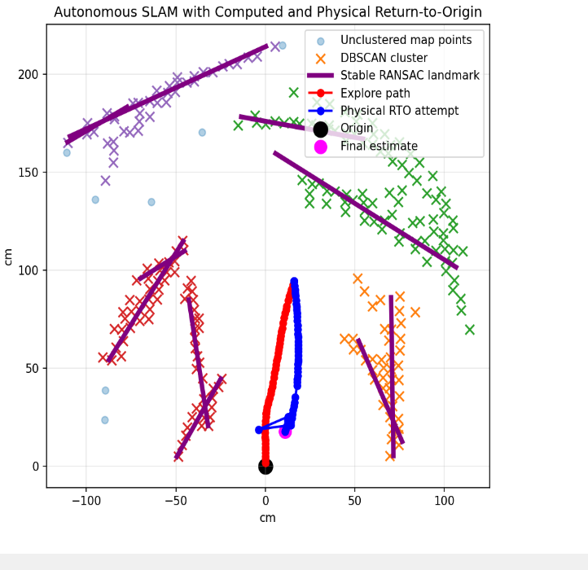
Figure 4 Figure 5

Above can be seen a recreated map of the environment (Figure 2) as well as 3 runs undertaken by the agent in that environment (Figures 3-5). In each subsequent run, the agent was allocated more moves to both explore the environment, and return to its original location, the number of allocated runs being 30, 40, and 50 respectively.

This was a substantially more crowded environment, with a number of distinct features for the agent to identify, and the closed nature meant that it was undertaking more turns and further refining its estimates of known environments, unlike in the case of the test runs undertaken in Figure 1, which was a more open environment wherein the agent largely would only proceed forward into unknown territory.

The smallest duration run occurring in Figure 3 seems to have been able to most accurately portray the geometry of the environment, identifying 5 unique, reasonably sized clusters, despite them being misplaced as compared to their real-world counterparts. On the other hand, Figures 4 and 5 depict large masses of data points with inaccurate clustering and identification of RANSAC landmarks. Although potentially a flaw of the parameters utilised for methods such as DBSCAN clustering, the more likely cause of these inaccuracies is the increasingly noisy environment as the agent’s estimated position drifts further from its actual position with the lengthier runs.

Despite the erroneous connections depicted between points in Figure 5, the agents seems to have been capable of identifying the corner (visible in the top right of Figure 2), which the run in Figure 3 was incapable of, suggesting that a higher number of runs is a prerequisite for identifying more complex landmarks, at the cost of more inaccurate identification of the position of these landmarks overall.

Visible in Figure 2 as a red dot is the agent’s starting position for each of the runs, and the numbered blue dots represent the position of the agent following the completion of each run. The return-to-origin attempt for Figure 4 (blue dot 2) was particularly inaccurate due to the agent getting stuck close to the wall and engaging in a constant cycle of turning left and right repeatedly for much of the return. This is an error caused by the simplistic action-choosing mechanism of the agent, with its only actions being TURNL, TURNR or DRIVE based on proximity to obstacles, it was unable to find a way to back up sufficiently to complete its return. This was amended in Figure 5, where the limit on how close the agent can be to an obstacle was dropped, and hence it was more accurately able to complete its run.

Despite Figure 5 returning an RTO error of ~35cm, which is quite a large displacement from the origin point, it does seem that allocating more runs to the return sequence of the agent correlates to a higher accuracy in returning to its origin point, potentially serving as evidence for the agent’s ability to somewhat localise itself in the environment, in spite of the accumulation of drift throughout this longer run. Throughout this return, the agent’s internal belief was that it had ended up in a position only ~5cm away from its origin point, meaning the agent overestimated its own return accuracy by a factor of approximately 7.

Another feature of note is the lack of any identification of points behind the agent’s starting position. Although the additional mapping of the environment while the agent was returning to its origin point could’ve yielded more detailed mapping, in reality due to the drift accumulation and the agent’s inability to accurately gauge what angle it was scanning, attempts to integrate mapping into the RTO process resulted in circular-shaped clusters from the blending of measurements taken as the agent turned around, causing major inaccuracy in the mapping, hence this feature wasn’t included in the final version of the software.

Overall, across all runs, return-to-origin error ranged from approximately 20 cm to 35 cm, increasing with traversal length. Mapping accuracy degraded correspondingly, with shorter runs producing coherent structures and longer runs exhibiting significant distortion.

9) Discussion
The aim of this project was to investigate the feasibility of performing Simultaneous Localisation and Mapping (SLAM) using a highly constrained sensor configuration consisting of a single ultrasonic sensor and an IMU. The results demonstrate that, while meaningful mapping and partial localisation are achievable under these constraints, performance is fundamentally limited by sensor noise, drift accumulation, and data association challenges.
Across all experimental runs, the system was able to identify major environmental features such as walls and, to a lesser extent, more complex objects such as corners and cylinders. This indicates that even sparse, low-resolution ultrasonic data can be sufficient to extract structurally meaningful landmarks when combined with appropriate filtering and clustering techniques. In particular, the use of DBSCAN clustering and RANSAC line fitting proved effective in identifying planar features, with wall structures consistently emerging as the most stable and accurately represented elements in the generated maps.

However, the quality of mapping degraded noticeably as run duration increased. Shorter runs (e.g., Figure 3) produced relatively coherent maps with identifiable clusters, whereas longer runs (Figures 4 and 5) exhibited significant distortion and erroneous clustering. This behaviour can be attributed primarily to the accumulation of drift in the IMU-based dead reckoning system. As discussed in the literature, double integration of accelerometer data introduces compounding error, and in the absence of corrective sensors such as wheel encoders or visual odometry, this drift becomes the dominant source of inaccuracy. The observed curvature in wall representations and misalignment of clusters are consistent with this effect.

The return-to-origin (RTO) experiments further highlight the limitations of the odometry system. Although the agent’s internal estimate suggested relatively small return errors (e.g., approximately 5.5 cm in one run), the actual displacement was significantly larger (approximately 20 cm). This discrepancy demonstrates a divergence between the estimated and true pose, reinforcing the conclusion that IMU-only odometry is insufficient for accurate long-term localisation without external correction mechanisms. Nevertheless, the fact that the agent was able to approximately return toward its origin suggests that coarse localisation is still achievable, particularly over shorter trajectories.

The landmark extraction process revealed an additional limitation related to the characteristics of ultrasonic sensing. While flat surfaces such as walls produced consistent and reliable returns, curved objects were frequently misrepresented, often appearing elongated or distorted in the generated maps. This is likely due to the wide beam angle of the ultrasonic sensor, which causes reflections from curved surfaces to be returned from multiple angles, leading to ambiguous spatial interpretations. This finding aligns with prior work highlighting the difficulty of accurate feature extraction using sonar alone.
From an algorithmic perspective, the FastSLAM-inspired particle filter approach demonstrated robustness to a degree of sensor noise, allowing the system to maintain a plausible pose estimate in early stages of exploration. However, the simplified implementation, particularly the use of a shared global map rather than per-particle landmark maps, likely reduced its ability to recover from incorrect data associations. As identified in the literature, incorrect associations can lead to catastrophic divergence, and this risk is amplified in low-resolution sensing scenarios such as the one explored in this project.
The results also provide insight into the trade-offs inherent in minimalist SLAM systems. Reducing sensor complexity significantly lowers cost and system complexity, but at the expense of reliability, scalability, and accuracy. While the system performs reasonably in small, controlled environments with strong geometric features, its performance deteriorates in more complex or extended scenarios. This suggests that there exists a practical lower bound on sensor complexity for SLAM, below which meaningful long-term localisation becomes infeasible.

Although IMU was meant to be the basis for yaw measurements throughout the project, it was eventually replaced with open-loop estimation of turns. While sufficient for the exploratory phase, IMU-only return-to-origin attempts resulted in catastrophic levels of drift and a complete inability for the agent to localise itself. Although some experimental purity was sacrificed through this change, it is still within the bounds set by the paper.

Finally, although GraphSLAM post-processing was proposed as a method for correcting accumulated drift, it wasn’t incorporated in the final version of the software due to its reliance on somewhat accurate data, which this agent was not able to adequately provide. GraphSLAM may find use in future, similar, work, wherein more sophisticated algorithms may be able to produce reliable data maps upon which post-processing techniques can be applied.

Overall, the findings of this project indicate that while minimalist SLAM is viable in a limited sense, the absence of complementary sensing modalities imposes significant constraints on performance. The system is capable of producing locally coherent maps and approximate localisation, but does not achieve the level of accuracy or robustness required for practical deployment.

9.2 Personal Reflection
Throughout this project I have encountered numerous roadblocks as a result of insufficient preparation. The scope of the work was constantly changing from my initial vision, as can be seen by the initial plan to utilise GraphSLAM which didn’t come to fruition. Part of this issue can be attributed to a lack of revisiting older work in the paper. I addressed the work in a very modular fashion, working through one section at a time, which may have overall led to a less cohesive experience in developing this project. In future works I would like to more strongly prioritise developing the work in a more uniform, incremental fashion, developing many aspects of the project at once, in order to have a more realistic view of what sort of objectives I should strive to achieve, as well as to allow the deliverance of a more enjoyable reading experience throughout the report.

On top of this, frequent hardware failures were causing delays in production, in particular on more than one occasion I had to repurchase a motor after one had broken. This could have been alleviated through prior research of more appropriate vendors and suitable hardware, and I consider this another aspect in which insufficient preparation caused me trouble throughout the project.

With regards to what went well, it was enjoyable to apply what I had been learning in my modules towards the work, such as the implementation of DBSCAN clustering influenced by CS3DM, allowing me to deepen my understanding of the lecture content while applying it in interesting ways. This was also my first instance of referencing such a large quantity of papers for a report, and I believe it has allowed me to hone my critical reading skills.

From a technical perspective, the project reinforced the importance of sensor fusion in SLAM systems. The reliance on IMU-based dead reckoning alone led to rapid drift accumulation, demonstrating that even robust probabilistic algorithms cannot compensate for fundamentally unreliable input data. Additionally, the limitations of ultrasonic sensing, particularly its poor performance on curved surfaces, highlighted the importance of sensor characteristics in determining the types of features that can be reliably extracted.

Overall, I believe this experience has contributed positively to my understanding of both my learning and my ability to structure a software engineering project. I believe that if I were to undertake a similar project, I would see vast improvements in my efficiency and quality of writing due to my time spent learning throughout this report.

10) Conclusion
This project set out to investigate the feasibility of performing Simultaneous Localisation and Mapping using a highly constrained sensor configuration consisting solely of an IMU and a single ultrasonic sensor. The objective was not to compete with conventional multi-sensor SLAM systems, but rather to explore the lower bounds of sensor complexity at which meaningful localisation and mapping can still be achieved.

The results demonstrate that it is possible to extract structurally meaningful information about an environment using this minimalist configuration. The system was able to identify key features such as walls and, in some cases, discrete objects, and to construct maps that exhibit a degree of geometric coherence. Furthermore, the agent was capable of approximate localisation, as evidenced by its ability to attempt return-to-origin behaviour with partial success.

However, the experiments also highlight significant limitations. The reliance on IMU-based dead reckoning resulted in substantial drift accumulation over time, leading to increasing divergence between estimated and true position. The ultrasonic sensor, while effective for detecting planar surfaces, proved unreliable for accurately representing curved or irregular objects. These limitations combined to produce degraded mapping quality in longer runs and reduced localisation accuracy.

Evaluation against the project objectives indicates that while a functional SLAM system was successfully implemented, its performance falls short of that required for robust or scalable applications. The findings suggest that a single ultrasonic sensor and IMU are insufficient for reliable long-term SLAM without additional sensing or correction mechanisms. As such, this work establishes a practical lower bound for sensor minimalism in SLAM systems.

Despite these limitations, the project contributes to an underexplored area of SLAM research by providing an empirical investigation into extreme sensor constraints. The system developed here demonstrates that even highly limited sensing configurations can yield useful insights into environmental structure, particularly in controlled settings. This has potential implications for low-cost robotics and educational platforms, where simplicity and affordability are key considerations.

Future work could focus on improving localisation accuracy through the integration of additional low-cost sensors, such as wheel encoders or multiple ultrasonic units, or through the application of more advanced filtering techniques, including full FastSLAM implementations or learning-based correction models. Additionally, the application of GraphSLAM as a post-processing step warrants further investigation, particularly in conjunction with improved front-end data quality.

In conclusion, while the minimalist SLAM system developed in this project demonstrates limited practical viability, it successfully identifies the constraints and challenges associated with extreme sensor reduction, and provides a foundation for further exploration of low-cost SLAM solutions.

11) References
[1] Ahn, S., Choi, J., Doh, N.L. and Chung, W.K. (2008) 'A practical approach for EKF-SLAM in an indoor environment: fusing ultrasonic sensors and stereo camera', Autonomous Robots, 24(3), pp. 315–335.
[2] Venkatesan, P., Pavitra, N. and Mohan, R. (2019) 'Performing SLAM using low-cost sensors for autonomous navigation in household environments', in Proceedings of the 2019 IEEE International Conference on Intelligent Techniques in Control, Optimisation and Signal Processing (INCOS). IEEE.
[3] Brossard, M., Barrau, A. and Bonnabel, S. (2020) 'AI-IMU dead-reckoning', IEEE Transactions on Intelligent Vehicles, 5(4), pp. 585–595.
[4] Dissanayake, M.W.M.G., Newman, P., Clark, S., Durrant-Whyte, H.F. and Csorba, M. (2001) 'A solution to the simultaneous localisation and mapping (SLAM) problem', IEEE Transactions on Robotics and Automation, 17(3), pp. 229–241.
[5] Durrant-Whyte, H. and Bailey, T. (2006) 'Simultaneous localisation and mapping: part I', IEEE Robotics & Automation Magazine, 13(2), pp. 99–110.
[6] Bailey, T. and Durrant-Whyte, H. (2006) 'Simultaneous localisation and mapping: part II', IEEE Robotics & Automation Magazine, 13(3), pp. 108–117.
[7] Newman, P., Leonard, J., Tardos, J.D. and Neira, J. (2002) 'Explore and return: experimental validation of real-time concurrent mapping and localization', in Proceedings of the IEEE International Conference on Robotics and Automation (ICRA 2002). IEEE, pp. 1802–1809.
[8] Leonard, J.J. and Durrant-Whyte, H.F. (1991) 'Mobile robot localization by tracking geometric beacons', IEEE Transactions on Robotics and Automation, 7(3), pp. 376–382.
[9] Wijk, O., Jensfelt, P. and Christensen, H.I. (1998) 'Triangulation based fusion of ultrasonic sensor data', in Proceedings of the 1998 IEEE International Conference on Robotics and Automation (ICRA). IEEE, vol. 4, pp. 3419–3424.
[10] Zhang, Y., Zhang, T. and Huang, S. (2018) 'Comparison of EKF based SLAM and optimization based SLAM algorithms', in Proceedings of the 2018 13th IEEE Conference on Industrial Electronics and Applications (ICIEA). IEEE, pp. 1308–1313.
[11] Dorvash, M., Eslamian, A. and Ahmadzadeh, M.R. (2023) 'Enhanced Unscented Kalman Filter-based SLAM in dynamic environments: Euclidean approach', arXiv [Preprint]. Available at: https://arxiv.org/abs/2312.12204
[12] Montemerlo, M., Thrun, S., Koller, D. and Wegbreit, B. (2002) 'FastSLAM: a factored solution to the simultaneous localization and mapping problem', in Proceedings of the AAAI National Conference on Artificial Intelligence (AAAI-02). AAAI Press, pp. 593–598.
[13] Thrun, S. and Montemerlo, M. (2006) 'The graph SLAM algorithm with applications to large-scale mapping of urban structures', International Journal of Robotics Research, 25(5–6), pp. 403–429.

